Assignment-1

Name: Shreyan Reddy Gangwar

ST ID:12599073

Stage 1: Data gathering:

Data is collected and saved in an appropriate format at this stage.

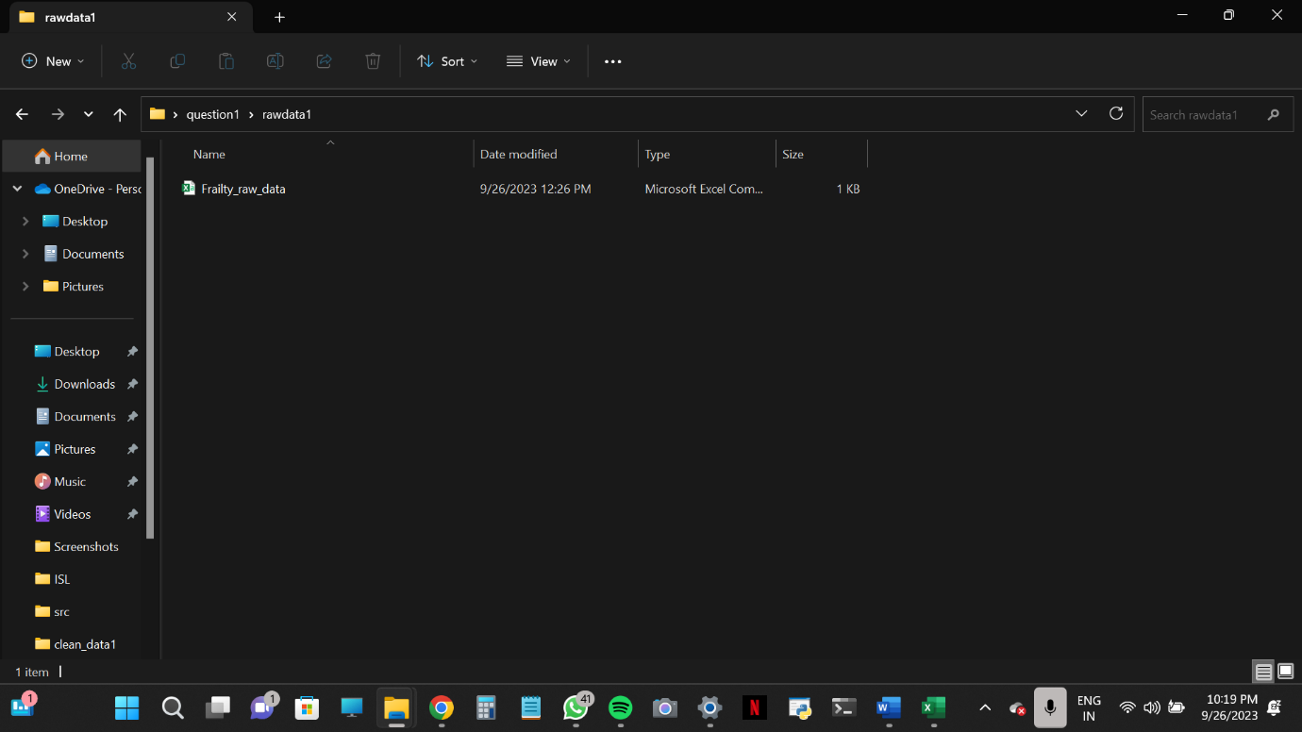

• Gathered data and saved it in.csv format in order to do the analysis.

Data Processing (Stage 2):

The collected data will be processed here in order to be ready for analysis.

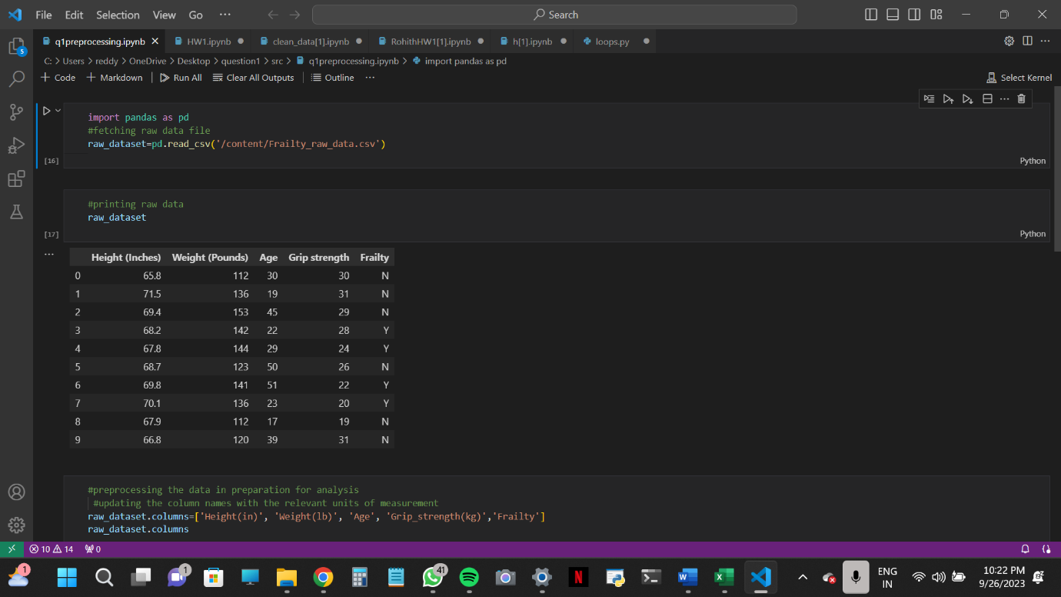

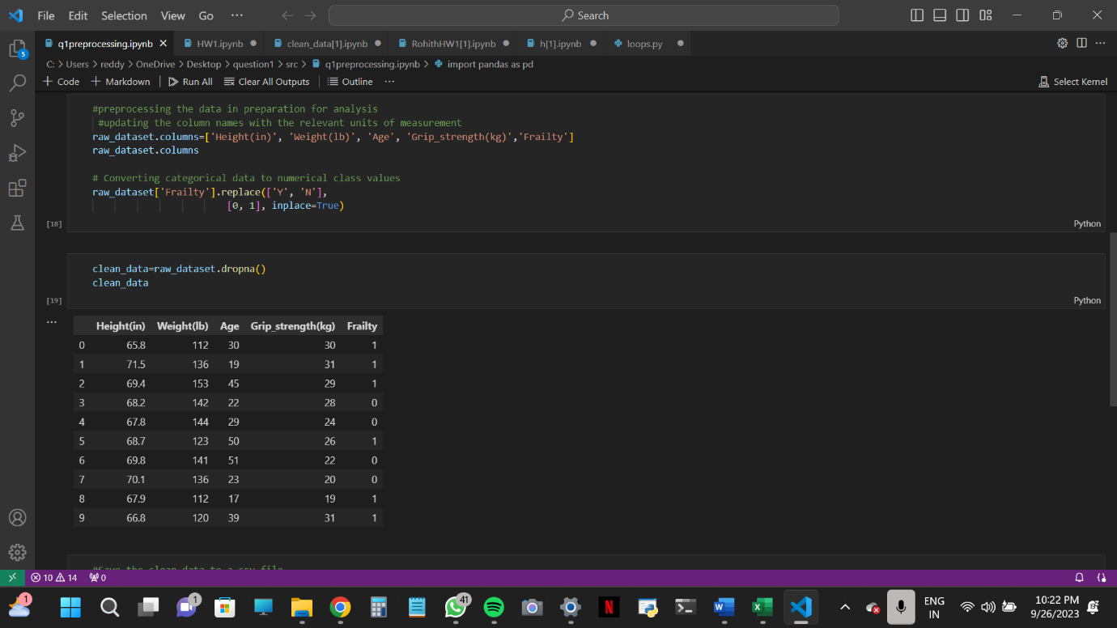

After importing the dataset, initial steps involve renaming columns for clarity and converting categorical data to numerical format for efficient analysis. The dataset is thoroughly checked for any missing values (NA occurrences). Ultimately, the cleaned dataset is prepared, ensuring it's primed for thorough utilization in subsequent analyses.

Stage 3(Analysis)

The algorithm generates personalized scatter plots for each data point in the dataset in Stage 3 of the analysis, demonstrating the association between height (measured in inches) and weight (reported in pounds). This image has been enhanced by the addition of new data points, providing for a more complete understanding of the relationship between these two variables. Each plotted point represents a person's unique height and weight combination, providing significant insights on potential associations. This step enables a more detailed exploration of the dataset, establishing the groundwork for more in-depth studies.

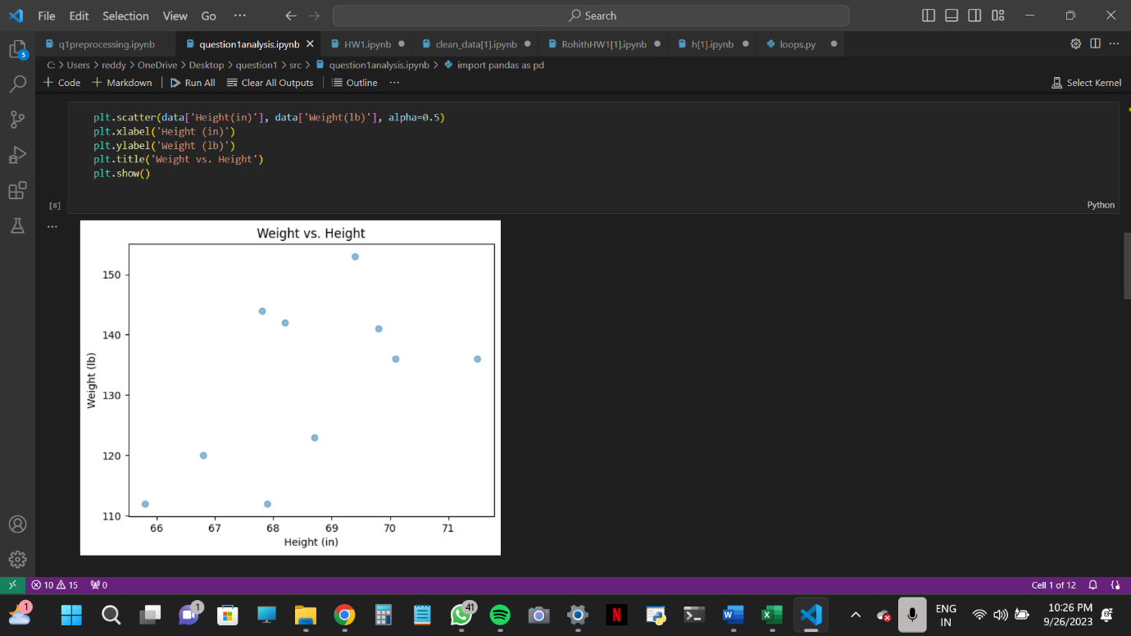

This code generates a count plot that displays the distribution of the dataset's 'Frailty' categories (probably binary values). It helps to visualize the frequency of people who are frail or not frail, demonstrating the prevalence of frailty in the sample.

